FEEG2001 Computing Assessment (Arduino Exercise)
Project Logbook
Submission deadline: Complete and submit ONE copy per team to E-assignments by 5PM Friday, 10th Jan.

Team Number: 10

Instructions for Project Logbook Content & AI use declaration

Please provide on the following pages:

- at least one image of your finished ‘Arduinosaur’
- your project background summary
- annotated code script
- AI/GenAI use declaration – each individual member of your team who used AI/GenAI in their work needs to fill this form and add it to the logbook submission.

Section headers and instructions will guide you through the process.

Please provide a printed copy of this logbook to your assessor in week 10. You can print in colour or black and white.

The printed copy will be used during your 15 minute ‘‘Arduinosaur’’ presentation. All deliverables are listed on the brief.

Table of Contents
Team Responsibilities 3
‘Arduinosaur’ Image(s) 4
Project Background Summary 5
‘Arduinosaur’ Code 6
GenAI Declaration Form 7
Declaration 9

Team Responsibilities
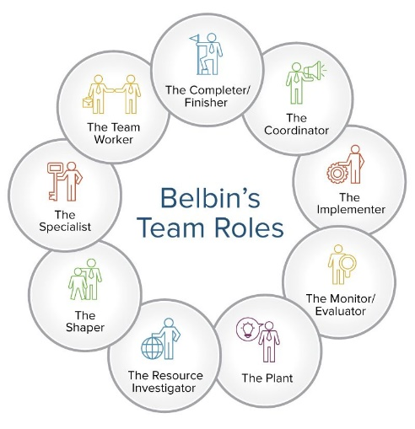
Responsibilities within the team could include (but are not limited to):
- Team leadership
- Communication
- Research
- Design development
- Programming and control
- Electronics
- Prototype Functionality
- Build quality
- Sustainability

Remember the Belbin team roles we introduced you to in part 1? You could indicate which role(s) each member of your team identifies with.
Figure 1 - Belbin's Team Roles (source: https://www.smartsheet.com/how-to-use-team-roles-to-boost-performance)
Team roles can be shared! Shared responsibility can help mitigate against illness or absence.

Name (insert names below) | Responsibility (list each team member’s responsibilities)
Yee Kai Xiong | - Movement (fear/aggression)  - Electronic Component Set up
Liang Zhen Yu | - Building Prototype  - Assembly
Teh Journ Xi | - Mouth (fear/aggression) biting motion  - Assembly  - Logbook
Ryan Lo Tzu Sheng | - Sound  - Assembly
Zhang Zhi Ming | - Initial concept Design  - Assembly

‘Arduinosaur’ Image(s)

[You may want to use a table to help with alignment if you have more than one image. Your image(s) should show your prototype in detail, zoom in, show your wiring and any interesting details.]

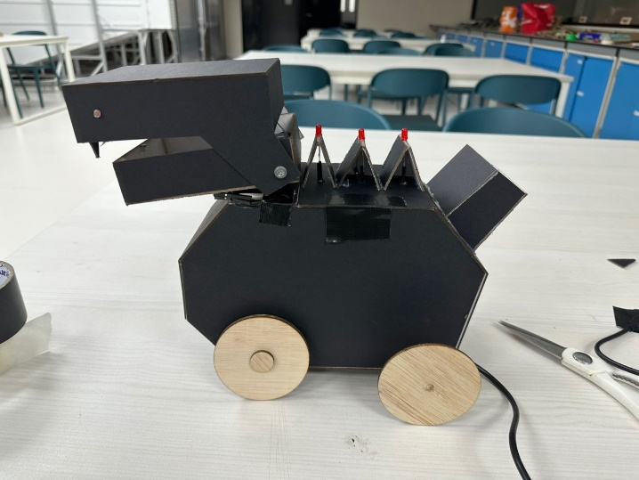 | 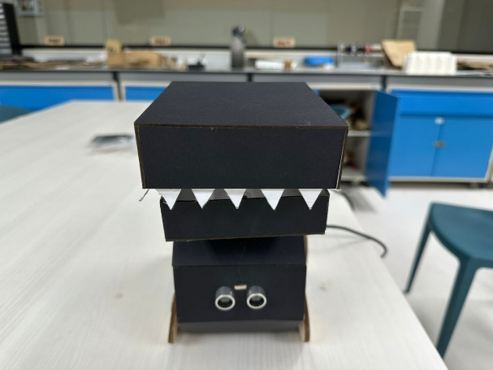
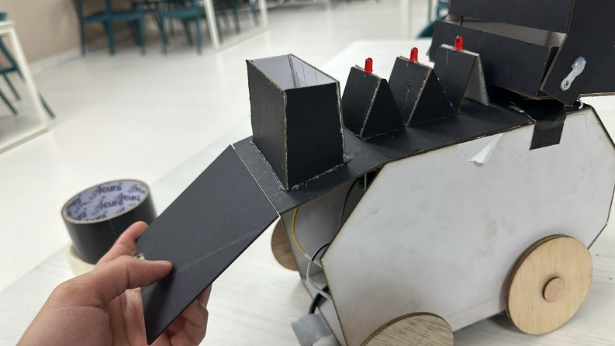 |  | 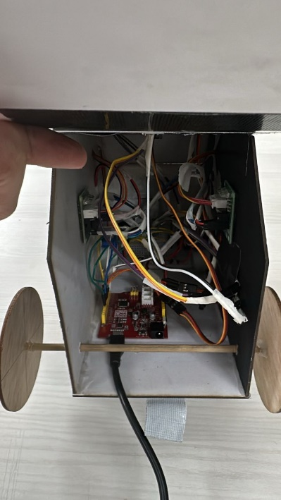

Project Background Summary
Initial Concept Sketch Design

1) Triduinodroid
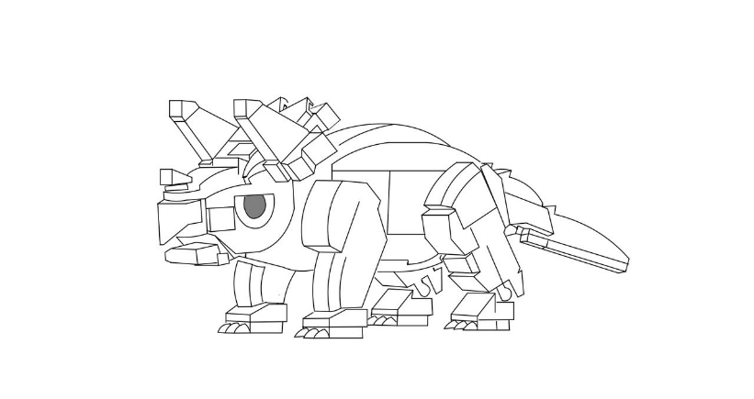

This Arduino-powered triceratops dinosaur design has an inside that contains motors, sensors, and an Arduino board enclosed by the modular, angular body. A wide base with movable legs powers the biting mouth with a servo motor for interaction. The swinging tail is servo-controlled, providing realism in simulating natural movement of the model. The angular, robotic design combines practicality with a space-age appearance using lightweight materials and simple part connection. In addition to providing interactive elements like obstacle detection and sound effects, the design ensures balance, adaptability, and ease of maintenance.

2) Rexduino
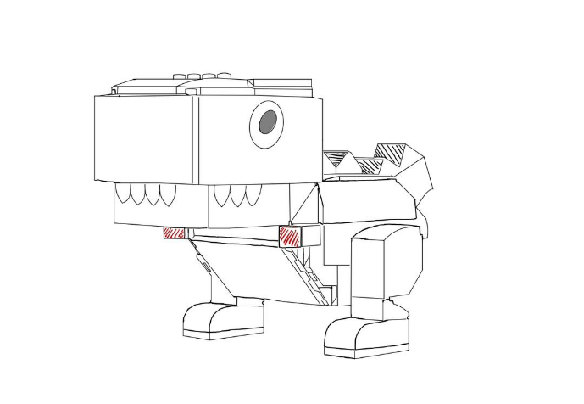
Sd

The following is a conceptual sketch for a robot dinosaur-an Arduino-powered robotic dinosaur, a T-Rex-that brings fun and functional robotics together: The T-Rex will have two eyes, an LDR in the block head, with triangular teeth to make him cool. The body is designed compact and angular, holding an Arduino, batteries, wiring inside, while for stability, the block legs take a room to house small servo motors that might be needed. The tail is made from overlapping angular segments that help with the balance, while the tiny arms capture the iconic posture of the T-Rex. Red highlighted sections indicate movable joints or areas where components like LEDs or servos could be embedded. The lightness of the material used, which could be plastic or even 3D-printed pieces, makes it perfect for assembly and customizing. This can be the base for a walking, tail-moving, and light-effect-equipped robot, among other features, that will make for an interactive project.

3) Pterodruinosaur
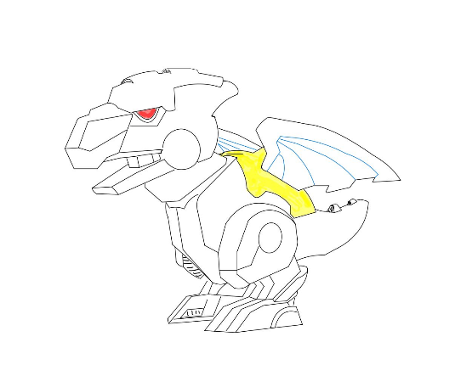

This is a concept piece for a robotic dinosaur mixed with dragon-like features, built using an Arduino-powered system. The head forms a bold, angular shape with a pronounced jaw having triangular teeth and a glowing red eye that may serve space for an LED or a sensor for interactive light effects. The body itself is compact, armored, and highlighted yellow at the joint or a structural decoration. Sleek, wing-like appendages with a blue outline complete this dragon-like creature and can be dynamic, movable parts. The legs are robust and mechanical; in movement, they are likely powered by servo motors, while the tail adds balance and visual appeal. Constructed from modular, lightweight materials, the design focuses on adaptability and functionality, turning it into a very good platform for interactive features like movement, lighting, or sound effects. The idea of a dinosaur-dragon hybrid merges creativity and technology in an interactive robotic project.

‘Arduinosaur’ Code
1) Define Pins, Libraries & Electronic Components Used
- LDR Resistor x 3 - measure light levels to control servos
- Red Led Light x 3 – adjust brightness based on conditions
- Servo x 2 (neck and mouth) – control positioning
- Stepper motor x 2 – forward & backward motion
- Arduino board x 1
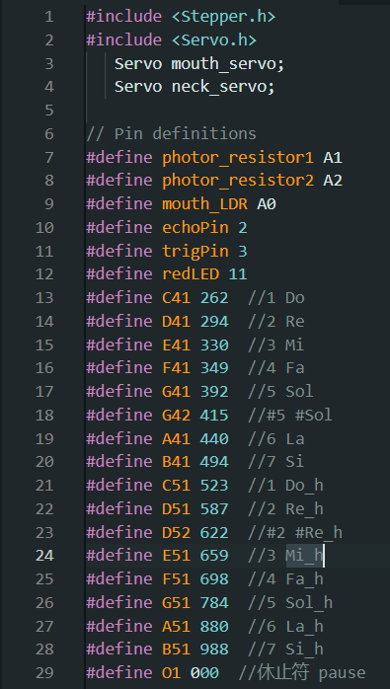
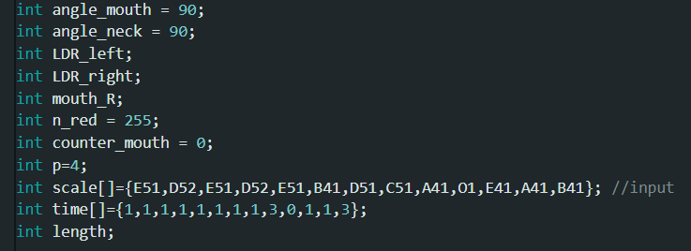

1) Libraries:
#include <Stepper.h> This includes the library required to drive a Stepper motor.
#include <Servo.h>: This library is used for the control of servo motors.
2)Servo Objects:
-Servo mouth_servo;// Creates a servo object to control the mouth's position.
-Servo neck_servo;// Servo controlling the position of neck.
3) Pin Definition
- Photoresistors (Light Sensors):
#define photor_resistor1 A1 //Analog pin A1 is connected to one light sensor.
#define photor_resistor2 A2// Analog input pin A2, the second light sensor is connected.
#define mouth_LDR A0 // A0: Analog pin A0 is connected to a light-dependent resistor used for detecting mouth-related light conditions
- Ultrasonic Sensor:
#define echoPin 2 // Digital pin 2 to the echo pin of the ultrasonic sensor.
#define trigPin 3 // Digital pin 3 connects to the sensor's Trig pin.
-Red LED:
#define redLED 11: Digital pin 11 controls the red LED.
- Tone Definitions: These constants define various musical notes using their frequency values:
#define C41 262 - #define B51 988, are musical notes defined by their frequencies in Hertz.
#define O1 000: For rest; this defines silence with a frequency of 0
4) Variables
angle_mouth = 90; // initial position for mouth 90 Degrees
angle_neck = 90; // initial position for neck 90 Degress
- LDR & Mouth Sensor
- int LDR_left; & int LDR_right; // variables store reading from left & right LDR
- int mouth_R; // variable to store value of light reading for mouth
- LED Control
- int n_red = 255; // control intensity of light sensor (255 max brightness)
- Counter & Control
- int counter_mouth; = 0 // counter to track no. of iteration/action of mouth activities
-int p = 4; // Pin 4 is used for buzzer output
- Sound Notes
- int scale[] = {E51,…etc}; // array for musical notes used to play the melody
- int time[] = {1,1,…. etc}; // corresponding timing values for melody
- length; // store length of the scale array
2) Void Setup (Motor Setup & Variable defining of electronic component used
- “const int stepsPerRevolution = 2048;” This defines the number of steps per full rotation for the stepper motor.

- “Stepper myStepper = Stepper(stepsPerRevolution, 7, 12, 8, 13);” This will instantiate a variable named myStepper as the Stepper object. Besides, it is connected with a PIN (7, 12, 8, 13) to control the motor.

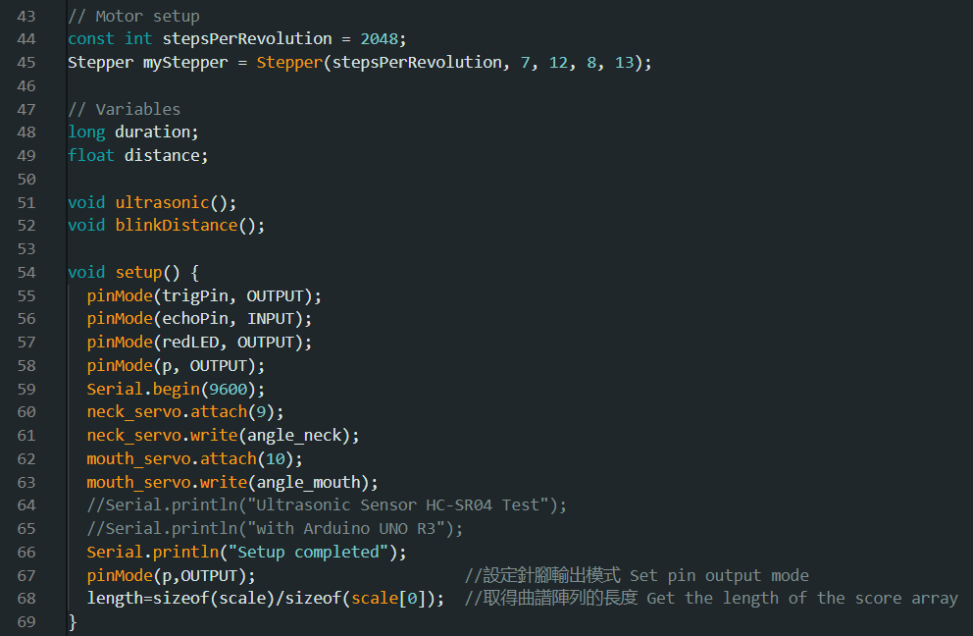
- “long duration;”: This variable will hold the time of flight for the ultrasonic pulse to come back and thus calculate the
distance.

- “float distance;”: This variable stores the calculated distance based on the pulse duration of the ultrasonic sensor.

- “void ultrasonic();” : This is the function prototype for the ultrasonic sensor that calculates and displays the distance.
- void “blinkDistance();” : This is the function prototype for controlling the LED based on the distance.

- pinMode(trigPin, OUTPUT); //Sets the trigger pin of an ultrasonic sensor as OUTPUT

- pinMode(echoPin, INPUT); //Sets the echo pin of the ultrasonic sensor as an INPUT

- pinMode(redLED, OUTPUT); //sets Red-led pin as an output pin

- pinMode(p, OUTPUT); // Sets pin p as an output (controlling the buzzer)

- Serial.begin(9600); // Initializes the serial communication at 9600 baud rate.

- neck_servo.attach(9); // Attaches the Neck Servo Motor on pin 9.

- neck_servo.write(angle_neck); //Set initial position of neck servo using variable angle_neck.

- mouth_servo.attach(10); // Attach mouth servo motor to pin 10.

- mouth_servo.write(angle_mouth); //Set initial position of mouth servo using variable angle_mouth.

- Serial.println("Setup completed"); //prints in serial monitor message showing setup completed

- pinMode(p,OUTPUT); //set again pin p as output.

- length=size of (scale)/size of (scale [0]); //This line of code finds the length of the array scale, presumably used to generate a tone or to play music, by dividing the total size of the array by the size of one element.

3) Mouth, Neck and Sound Output

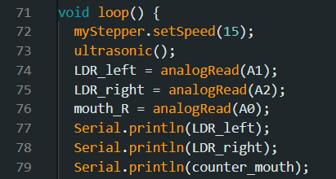

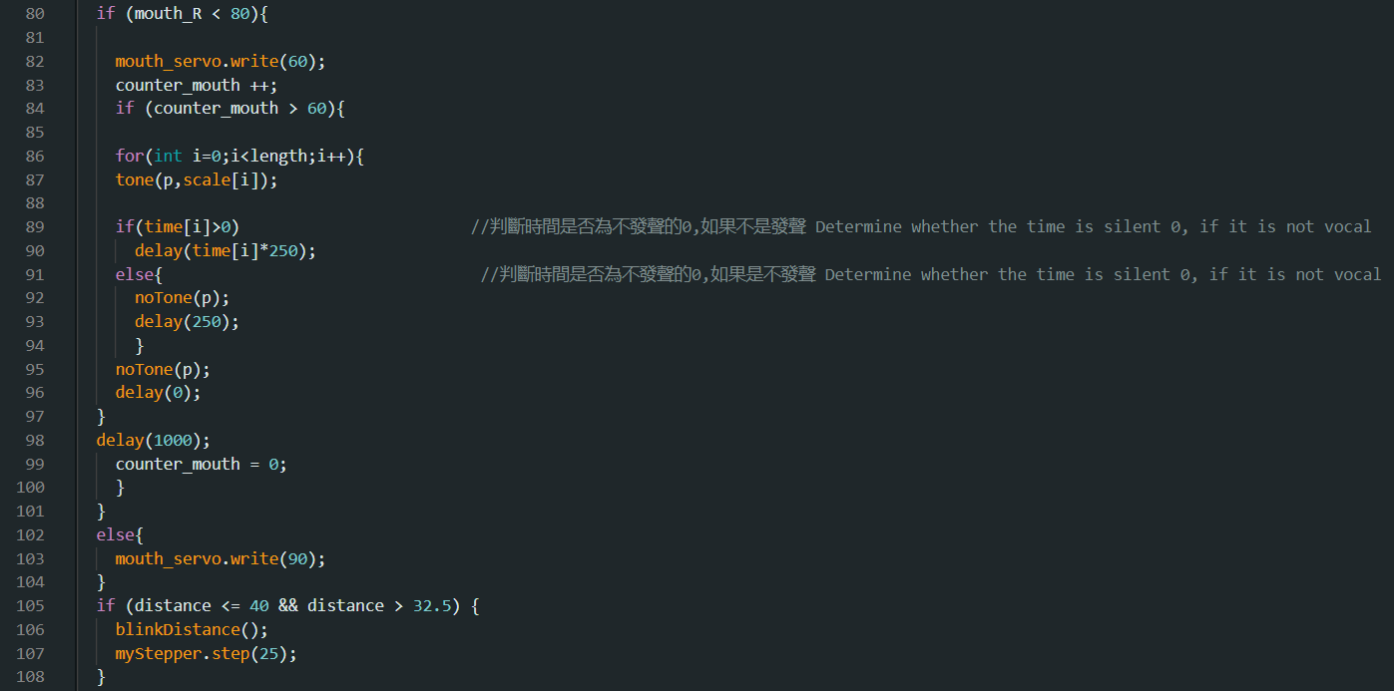
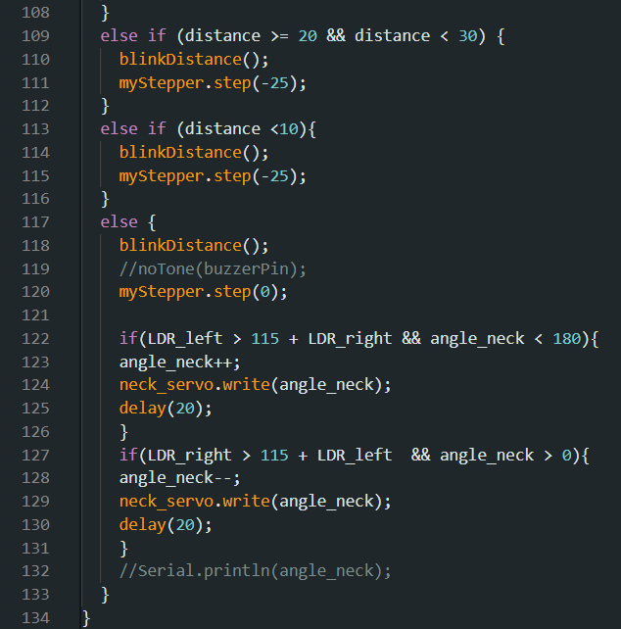

1) Mouth Servo Control: If mouth_R is less than 80, the mouth servo moves to position 60 and a sequence of tones is played depending on arrays of sound frequencies and durations. After 60 iterations, the counter resets. If mouth_R is 80 or above, the mouth servo moves to position 90.

- Condition: if (mouth_R < 80)
- Action: The servo will be set to position 60 (mouth_servo.write(60)), and a counter is incremented (counter_mouth).
- Further Condition: If counter_mouth exceeds 60:
A loop runs through a scale array. The function tone (p, scale[i]) plays the tones, and the delays between the tones are handled by delays depending on time[i]. If time[i] is > 0, it waits for the length of the sound (times 250ms); if time[i] equals 0 -not producing any sound-it stops the tone using noTone(p) and creates a delay for 250ms.
When the loop is over, it resets the counter (counter_mouth = 0), waiting for the next action to take place.

  - If mouth_R >= 80, the mouth servo is set to position 90 (mouth_servo.write(90)).

Expected Result: The mouth servo will move to different positions and play tones when certain conditions on mouth_R are met.

2) Stepper Motor Control: The stepper motor adjusts its position depending on the distance sensor:

- If the distance <= 40 && distance > 32.5: The distance sensor detects an object in the range between 32.5 cm and 40 cm.
  - Action: Call the blinkDistance() function probably to indicate some visual or signal feedback, and move the stepper motor forward by 25 steps myStepper.step(25).

- If the distance >= 20 && distance < 30: The distance is between 20 cm and 30 cm.
  - Action: Call the blinkDistance() function and move the stepper motor backward for 25 steps: myStepper.step(-25).

- If the distance < 10: Distance less than 10 cm
  - Action: Call the blinkDistance() function and move the stepper motor backward by 25 steps, myStepper.step(-25).

- Else (no movement): If all of the above conditions are not met, then the stepper motor will not move-myStepper.step(0).

Expected Result: The stepper motor will move forward or backward depending on the detected distance.

3) Neck Servo Control: The angle of the neck servo depends on the reading of the two LDRs. It turns neck a little bit to left or right between the range 0 to 180 degrees when one LDR detects more light compared to another

- If LDR_left > 115 + LDR_right and angle_neck < 180 then increment the neck servo angle by 1 degree and move the neck servo to that angle using neck_servo.write(angle_neck).

- If LDR_right > 115 + LDR_left and angle_neck is greater than 0, decrease neck servo angle by 1 degree and neck servo moves to that degree position.

- Delay (20) allows enough time for a move of the servo before adjustment is performed.

Expected Result: The neck servo will adjust based on the difference in light between the two LDRs, turning left or right as needed.

4) Ultrasonic Sensor Function
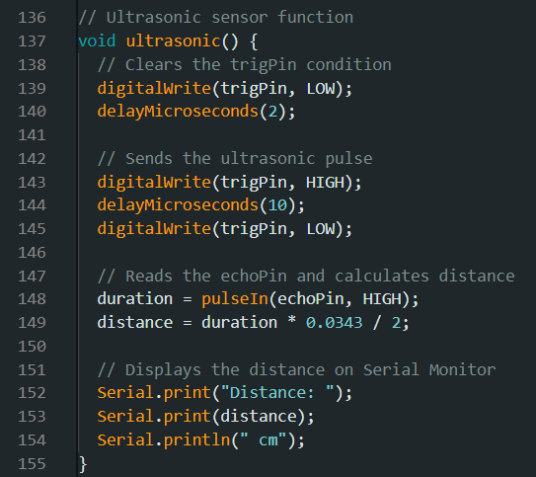
Expected Result: The function continuously calculates and displays the distance measured by the ultrasonic sensor, printing it to the Serial Monitor in “cm”

Overview of the Function:
1)Trigger Pin Setup:

First, the trigger pin (trigPin) is pulled LOW for a short period to make sure any residual signals are off, digitalWrite(trigPin, LOW);;

Then it waits for 2 microseconds, delayMicroseconds(2);;

2)Sending the Ultrasonic Pulse:

It pulls the trigger pin HIGH for 10 microseconds, digitalWrite(trigPin, HIGH); delayMicroseconds(10); that sends an ultrasonic pulse.

After 10 microseconds, the trigger pin is pulled LOW, digitalWrite(trigPin, LOW);;

3)Echo Pin Reading:

It waits for the echo pin (echoPin) to receive the reflected pulse. The pulseIn() function measures how long it takes for the echo to return.

The duration of the pulse is stored in the variable ‘duration’.

4)Calculating the Distance:

The distance is calculated using the formula:

Distance = (duration×0.0343)/2

where:
- duration is the time it takes for the ultrasonic pulse to travel to the object and back.
- 0.0343 cm/μs = round-trip speed of sound in air
- The division by 2 accounts for the fact that the pulse travels to the object and back.

4)Displaying the Result:
In this line, "Distance: " is printed on the Serial Monitor followed by the value of the variable distance and appending the unit "cm".

5) Led Function:
- adjusts the brightness of a red LED based on the measured distance, modifying the LED's intensity depending on specific distance ranges.
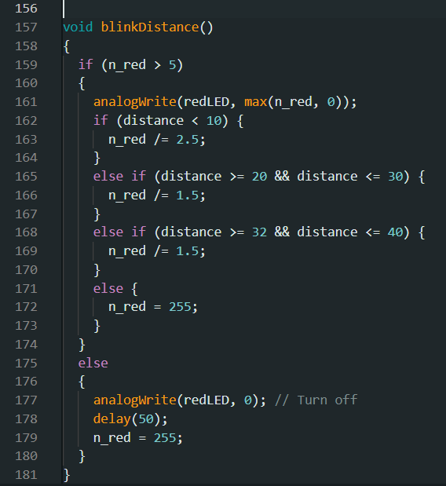
1)Valid Red LED Value Check:

- In case, n_red > 5, the red LED intensity value n_red is already higher than the set threshold value, the function continues in further dimming the LED.

2) Change the Brightness of the LED Based on Distance:

- The red LED brightness is set using analogWrite(redLED, max(n_red, 0));, where the intensity of the LED is varied with n_red. The max(n_red, 0) ensures that the value of n_red can never be less than 0, meaning the LED cannot be dimmed down to a negative value.

Then, depending on the distance:

- If the distance is less than 10 cm, it decreases n_red by a factor of 2.5, thus dimming the LED.

- In case the distance falls between 20 cm and 30 cm (inclusive), it decreases n_red by a factor of 1.5, which makes the LED dimmer but not as much compared to when the distance is very close.

- If the distance is within a range from 32 to 40 cm, n_red is again reduced by a factor of 1.5

- If over 40 cm: reset the n_red to 255 (bright).

3) If n_red is less than 5:

- If the value of n_red is 5 or less, the red LED turns off setting it to analogWrite(redLED, 0); with a short delay of 50 milliseconds - delay(50);.

- After the delay, n_red is reset to 255 for maximum brightness in future calculations.

Expected Results:
- With the reduced distance, the brightness of the LED decreases as in a reduction of n_red.
- If the object is very close, less than 10 cm, the LED dimmed considerably.
- If the object is further away, over 40 cm, the LED is at full brightness.
- If n_red is below threshold (< 5), the led blinks off and after returning to full brightness.
5)Final Electronic Component Circuit Diagram

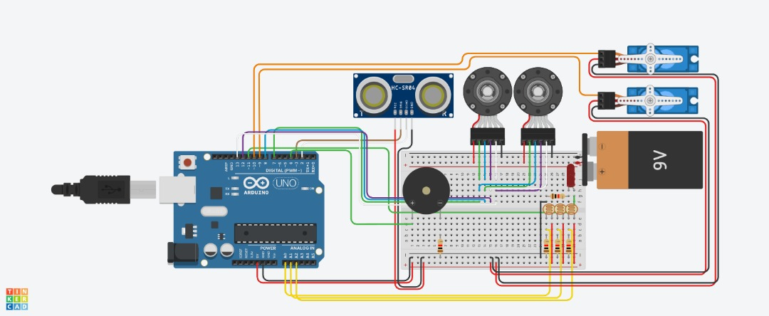
- Arduino board x 1
- Ultrasonic sensor x 1
- Buzzer x 1
- Stepper motor x2
- 3V battery x 3
- Servo x 2
- LDR x 3
- Red LED x 3
- Resistor 100 Ohms
GenAI Declaration Form
Generative AI (GenAI) is defined* here as Artificial Intelligence (AI) technology that automatically generates content in response to user prompts. The generated content includes texts, software code, images, videos, and music.
Student: For Tiers 2/3, complete “2. Declaration” and submit with your assignment.
Definition:
Tier 1: No use
Students are prohibited from using any GenAI tools for their assessed work.
This includes entering any part of an assignment or assessed work to GenAI, whether by pasting/typing text, uploading files, or describing content directly or through plugins.
Basic tools that assist spelling and grammar, translation and calculation without generating new content or ideas, can be used unless specified otherwise by the assessment setter. GenAI may be used to explain lecture slides and notes to enhance understanding of relevant topic areas.
Tier 2: Assistive use
Students may use GenAI to help achieve intended learning outcomes, which are still achievable without GenAI use. The assessment setter must specify allowed use cases using the Specification Table. Students must complete “2. Declaration”.
Tier 3: Integral use
Students must use GenAI tools to achieve the intended learning outcomes. The assessment setter must specify the allowed use cases using the Specification Table. Students must complete section “2. Declaration”.
1. Tier Specification
Enter “All” if applied to entire assignment, or specify applicable question numbers/parts:
Module Code | Assignment name / description
FEEG2001 | Computing Assessment
Applies to | Assigned tier
 | Tier 1: No use (no further information is required on this form)
All | Tier 2: Assistive Use (fill Declaration Requirement and Specification Table)
 | Tier 3: Integral Use (fill Declaration Requirement and Specification Table)

Declaration Requirement (Tier 2/3 only): For Tier 2 and 3 students must complete the standard declaration at the end of this form unless it is explicitly stated as unnecessary below. Additional and other requirements should be specified here (modify the default ‘Applies to’ entries as required):

Applies to | Additional GenAI declaration requirements
Not needed | Full chat logs must be submitted (additional)
Not needed | Annotated version of assignment must be submitted (additional)
 | Standard declaration not required (student info and academic conduct boxes are still required), e.g., if GenAI declarations already form part of the main submission
Not needed | Other (please specify below)

Specification Table (Tier 2/3 only): Enter “All” or specify applicable question numbers/parts:
ID | Applies to | GenAI use case | Definition | Example prompts
Assistive: A1-6 are assistive GenAI use cases where “outputs produced by GenAI are not a part of the final submission material”.
A1 | All | Debugging code | Inputting code and error messages into GenAI to identify syntax or logical errors. | "Here are 20 lines of Python code and an error message. Identify why this error is occurring."
A2 | All | Critiquing spelling punctuation and grammar | Using GenAI to identify and suggest corrections for spelling, punctuation, and grammar mistakes without changing the overall meaning. | "Check my technical report on fluid dynamics for spelling, punctuation, and grammar mistakes without altering the overall meaning."
A3 |  | Essay planning | Using GenAI to help outline the structure and subsections of an essay based on the topic and research findings. | "Create an outline for an essay on the impact of automation on manufacturing, including suggested sections and subsections."
A4 | All | Source recommendations | Using GenAI to find and suggest relevant academic or credible sources related to the assessment topic. | "Find peer-reviewed articles on renewable energy solutions for my mechanical engineering research project."
A5 | All | Suggesting design solutions | Using GenAI to generate ideas and suggestions for solving specific design challenges. | "Suggest amplifier circuits that require low power consumption while having little noise."
A6 |  | Function and library recommendations | Using GenAI to suggest appropriate functions or libraries to use in programming tasks. | "Recommend Python libraries suitable for simulating electrical circuits.”
Generative: G1-6 are generative GenAI use cases where “outputs produced by GenAI are a part of the final submission material”.
G1 | All | Generating or correcting a segment of Code | Using GenAI to write or correct a segment of code based on a given prompt describing the desired functionality. | "Write Python code to control a servo motor using a Raspberry Pi."
G2 | All | Rewriting written material | Using GenAI to help restructure and modify the text in a document, including grammar and stylistic improvements. | "Rewrite my technical report on the design of an electronic circuit to improve clarity and coherence."
G3 | All | Generating images / figures | Using GenAI to create diagrams, charts, or figures for use in a report or presentation. | "Generate a schematic diagram of a microcontroller-based temperature control system."
G4 |  | Language translation | Using GenAI to translate text from one language to another and correct grammar mistakes in the translated text. | "Translate this technical documentation from German to English and correct any grammar mistakes."
G5 |  | Writing sections of a report or producing slides in a presentation | Using GenAI to generate parts of a report, such as abstracts, introductions, or conclusions. | "Write an abstract for my research paper on the optimisation of power systems."
G6 |  | Analyse data that is not subject to additional ethics approval | Inputting large datasets into GenAI to identify trends, correlations, and insights. | "Analyse this dataset of sensor readings from an IoT network to identify trends and generate visualisations."

ID | Applies to | Other allowed GenAI use cases (define below and assign an ID)
For more information on completing this form visit: https://sotonac.sharepoint.com/sites/FEPSGenAI

Declaration
All students must complete this section for all Tier 2 and 3 assessments
One declaration is required for each student for this group submission. Simply copy and paste the form below for those students who have chosen to use AI/GenAI.
Answers on this form will NOT IMPACT your marks unless an Academic Responsibility and Conduct breach is found.
General university guidance regarding GenAI can be found via the library
Name |  | Student ID
Teh Journ Xi |  | 34403655
Module Code |  | Assignment name / description
FEEG2001 |  | Computing Assessment (Arduino Exercise)
Have you used GenAI? (Tick for yes) | ☐ | Date: 31/12/24
Which GenAI tools have you used? (Include version / leave blank if not used)
No

Name |  | Student ID
LO TZU SHENG |  | 34396101
Module Code |  | Assignment name / description
FEEG2001 |  | Computing Assessment (Arduino Exercise)
Have you used GenAI? (Tick for yes) | ☐ | Date: 31/12/24
Which GenAI tools have you used? (Include version / leave blank if not used)
No

Name |  | Student ID
Yee Kai Xion |  | 34396888
Module Code |  | Assignment name / description
FEEG2001 |  | Computing Assessment (Arduino Exercise)
Have you used GenAI? (Tick for yes) | ☐ | Date: 31/12/24
Which GenAI tools have you used? (Include version / leave blank if not used)
No

Standard declaration: Complete this for all Tier 2 and 3 assessments unless specified as not required
For each GenAI use (see definitions and codes over the page), summarise which questions and how each was used (suggest 1 or 2 sentences per use category)
If Full chat logs and/or annotated assignment versions are required, examples can be found via the link in the footer.
Academic Conduct
I acknowledge I have answered honestly on this declaration form | ☒
I understand if I was unsure about whether my actions met academic conduct requirements, it is my responsibility to confirm with the teaching team prior to submission | ☒
I am aware of and have critically reviewed the content generated by GenAI used in this submission. I accept responsibility for this content and can be asked about it in the future | ☒

